***Module C: Debugging***

1.Test program and methodology, including a list of requirements for the system and the procedure for performing the test, presented in the form of a table.

|  |  |  |
| --- | --- | --- |
| Description of system requirement No. 1 | | |
| No. | Check procedure | Expected results |
| 1 | Load module | To grab or drop things smoothly. |
| 2 | Stability of the drone | Stable flight. |
| 3 | Colabration between the load module and drone. | Successful grab or drop during flight. |

1. Test report with photos, videos, links to files for each of the system requirements.

|  |  |  |  |
| --- | --- | --- | --- |
| No. | Name of the requirement for the System | Feature availability mark | Test result |
| 1 | Throwing device | Drop things based on requirement. | Complete |
| 2 | Objects of various shapes, size and weight. | Be easy to be grabbed. | Complete |

1. 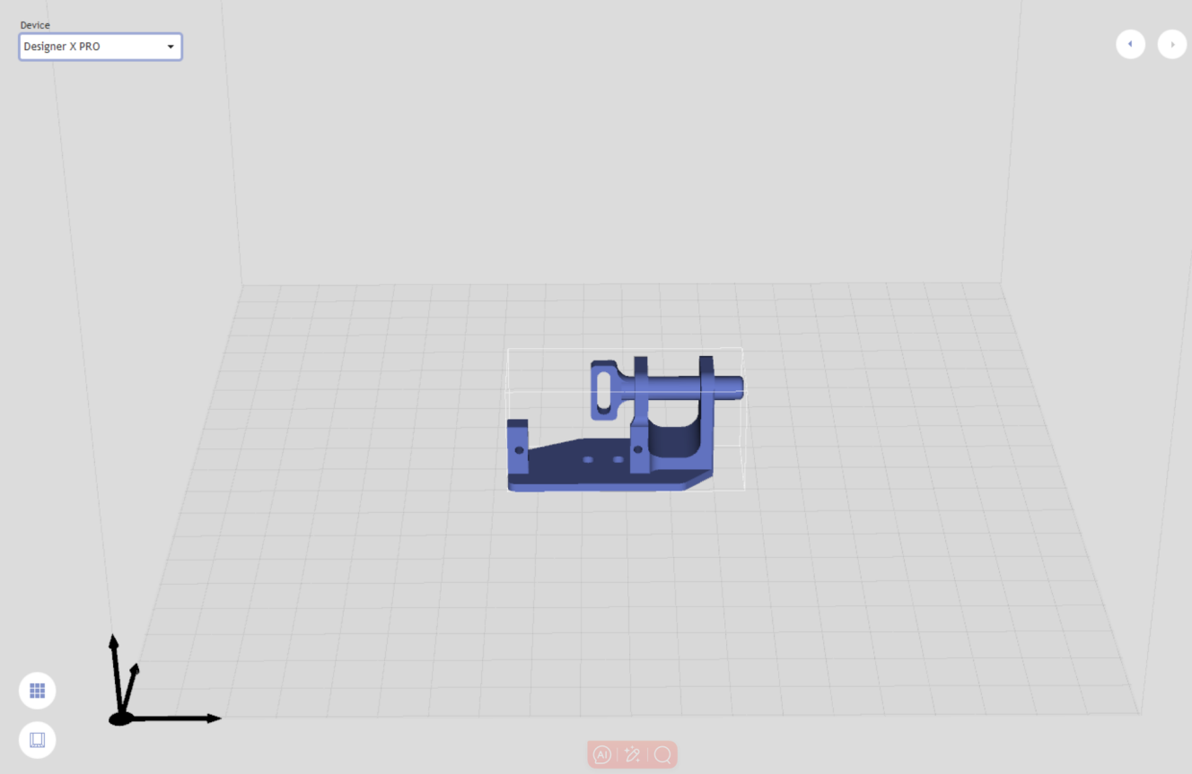Prototype of throwing device

